**RedHat System Administration**



**Shenouda Nabil Lamei**

**RedHat Final Exam**

**Supervised by.**

**Eng / Romany Nageh**

**1- Configure the network**

**a) Assign Hostname and Ip address for your virtual machine.**

**Hostname sh-nabil710**

**IP Address 192.168.10.10**

**Net-mask: 255.255.255.0**

**Gateway: 192.168.10.2**

**Name-server 192.168.10.2**

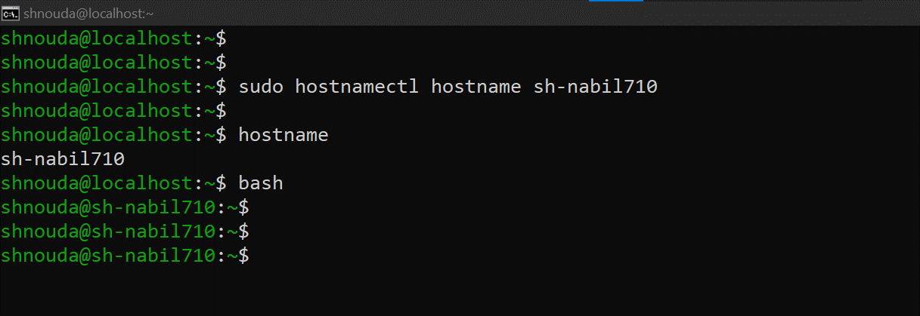

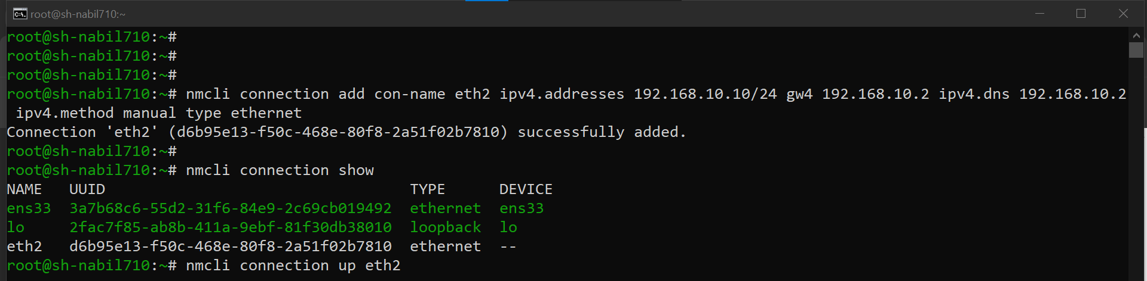



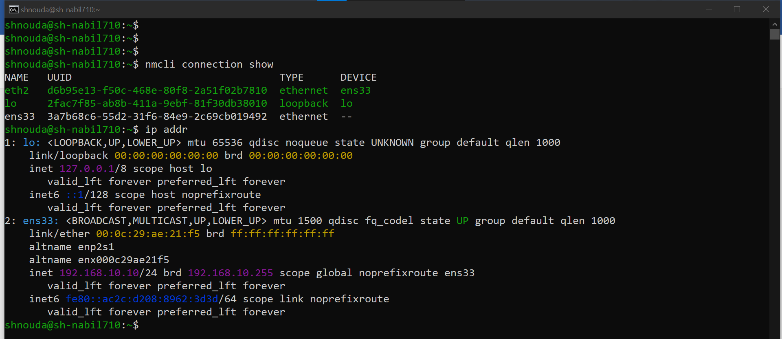

**2- Create a repository file 🡪 Create a repository file**

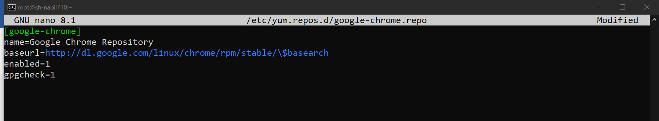

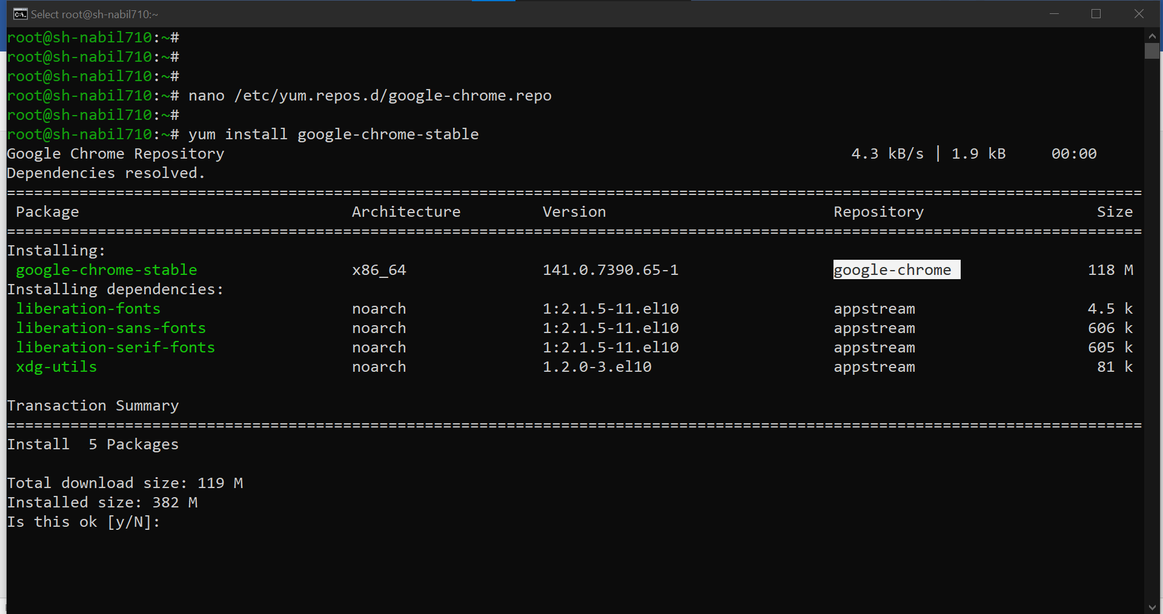

**Configure the Selinux**

**The webserver is running on non-stardard port 82 having a issue serve the web content. Debug**

**and fix the issue:**

**a) The webserver can serve all the existing HTML file located at /var/www/html directory**

**(Don't alter or remove any files in this directory)**

**b) The webserver can serve the content on port 82.**

**c) Make the content accessible.**

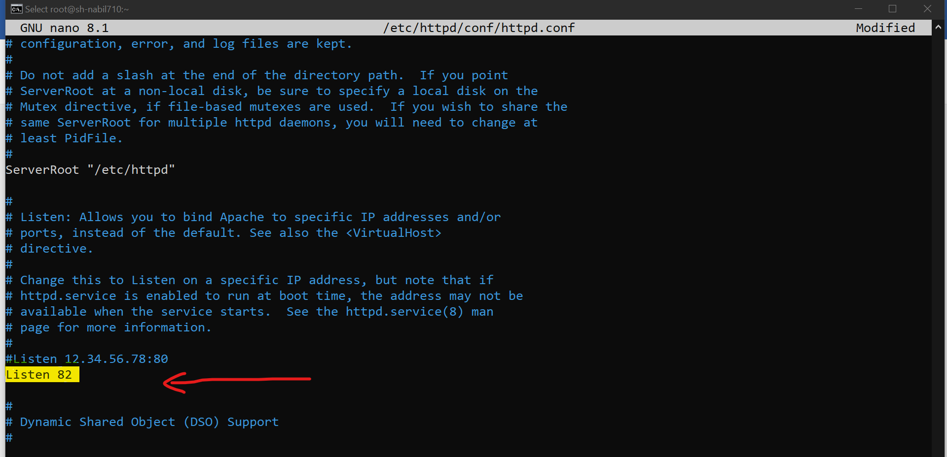

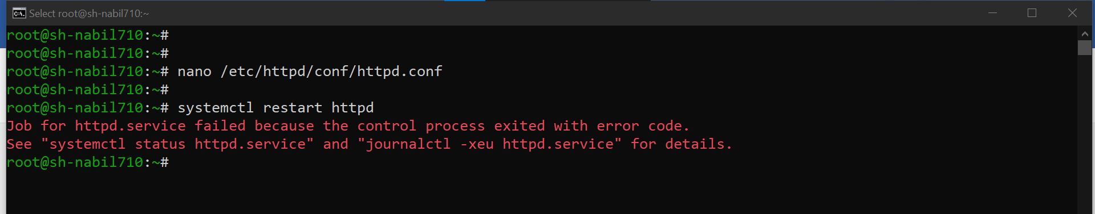

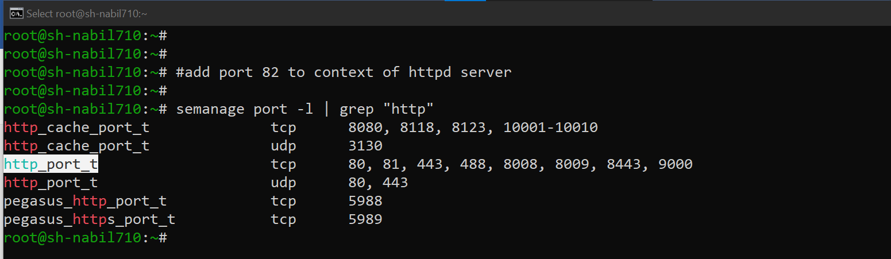

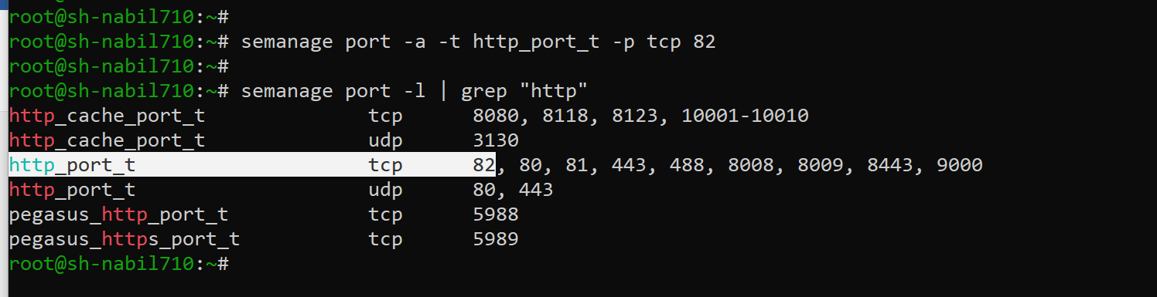

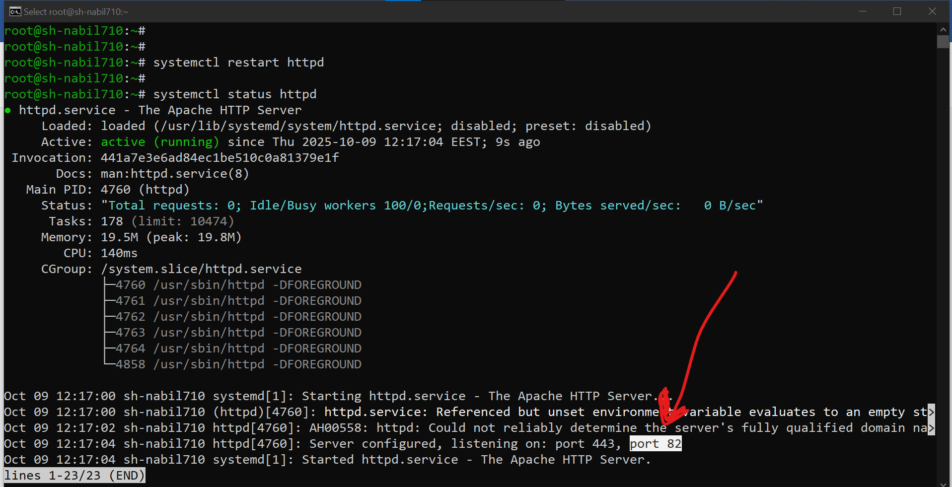

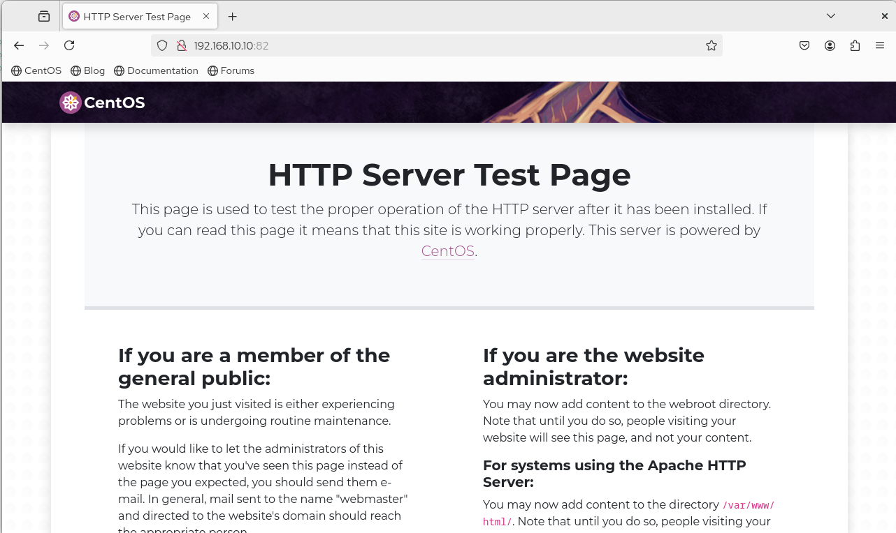

* **I will make my page under /var/www/html .**



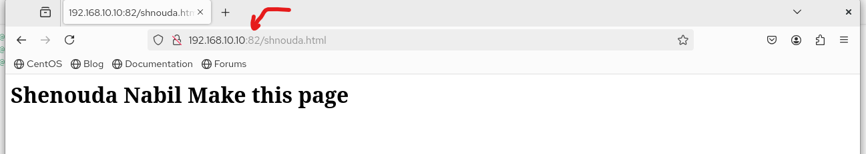

**4. Create the following users, groups and group memberships:** **a) A group named admin.**

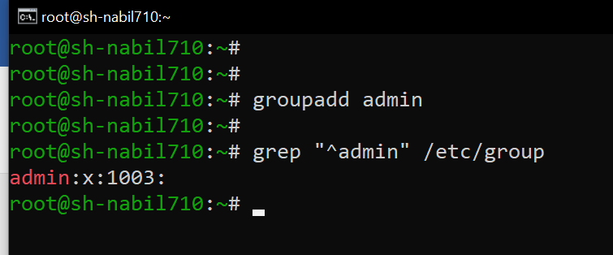

**b) A user harry who belongs to admin as a secondary group.**

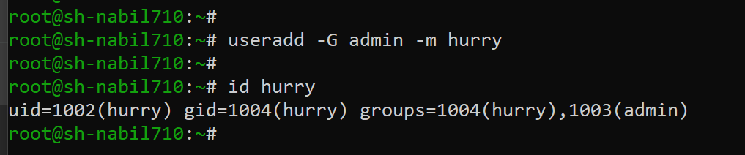

**c) A user natasha who belongs to admin as a secondary group.**

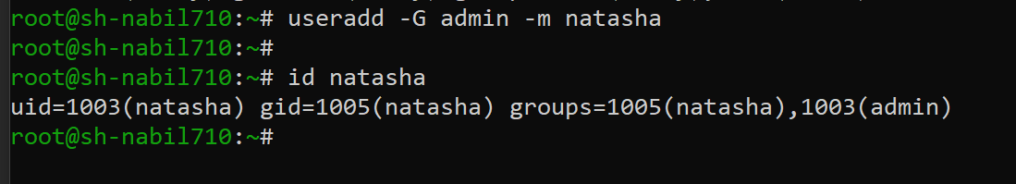

**d) A user sarah who does not have access to an interactive shell on the**

**system and who is not member of admin.**

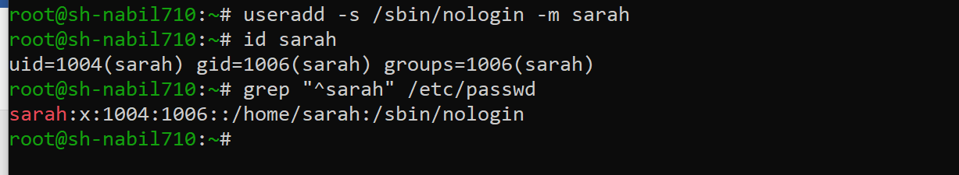

**e) harry, natasha and sarah should have password of password.**

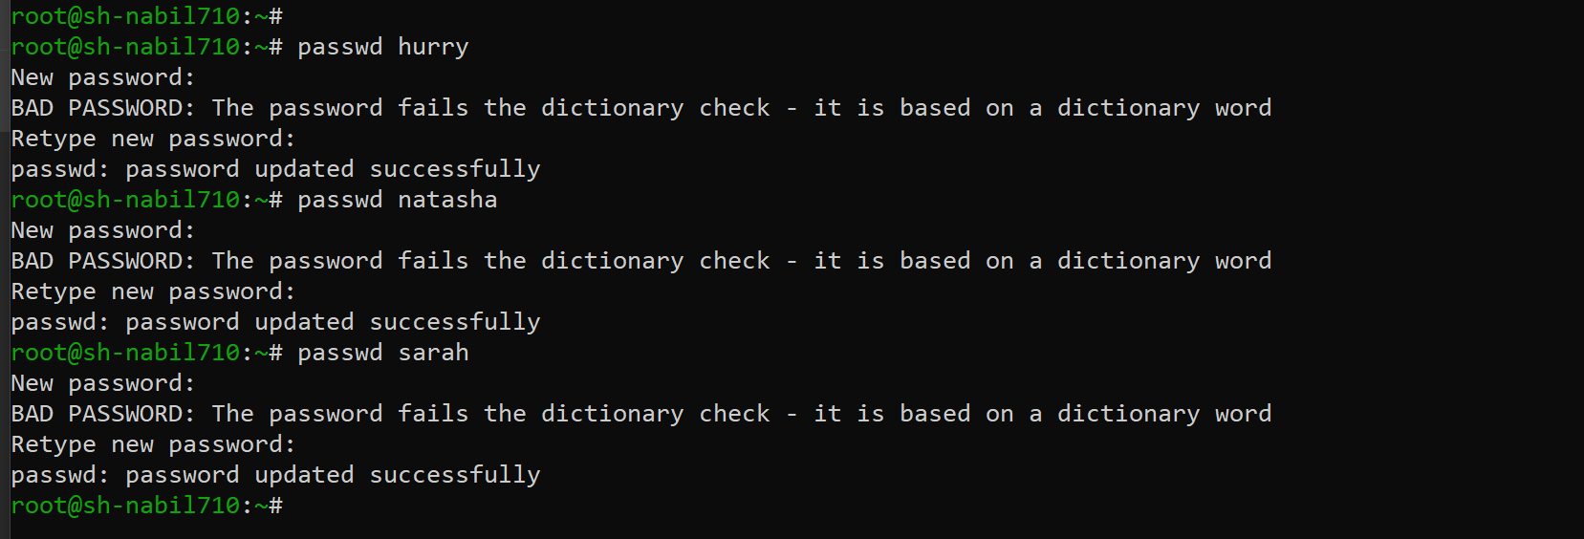

**5. Create a collaborative directory /common/admin with the following characteristics:**

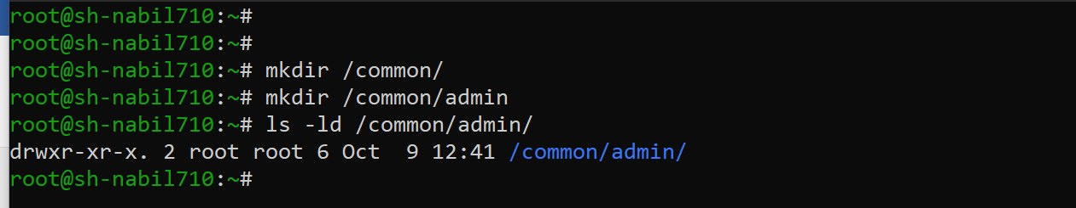

**a) Group ownership of /common/admin is admin.**

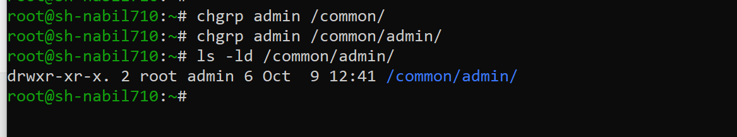

**b) The directory should be readable,writable and accessible to**

**members of admin, but not to any other user.**

**(It is understood that root has access to all files and directories on the system.)**

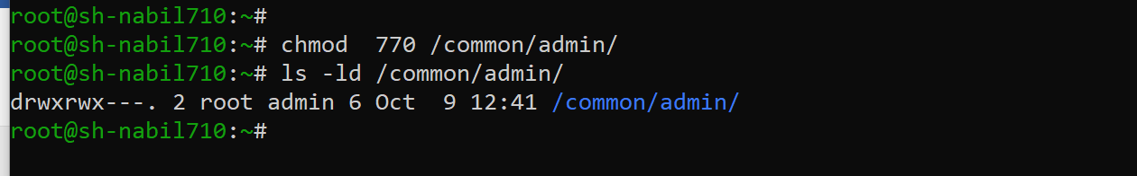

**c) Files created in /common/admin automatically have group ownership set to the admin group**

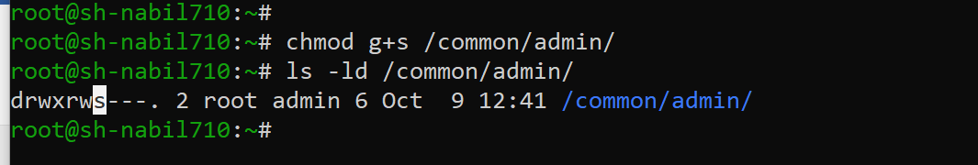

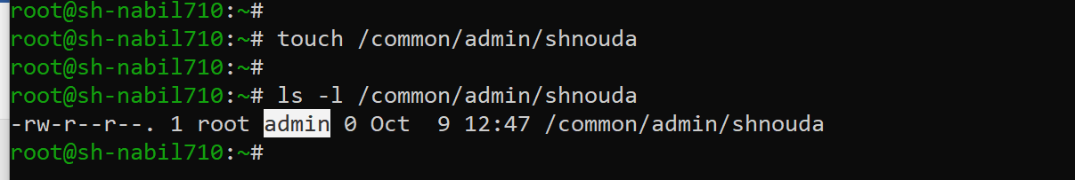

**7. The user harry must configure cron job that runs daily at 12:30 local time and execute /bin/echo "hello".**

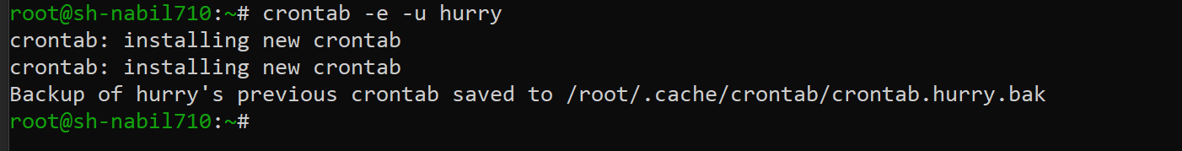

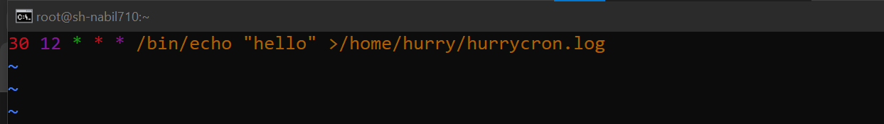

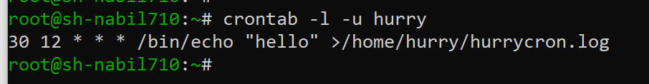

**Verify the cron job 🡪 I will change the time.**

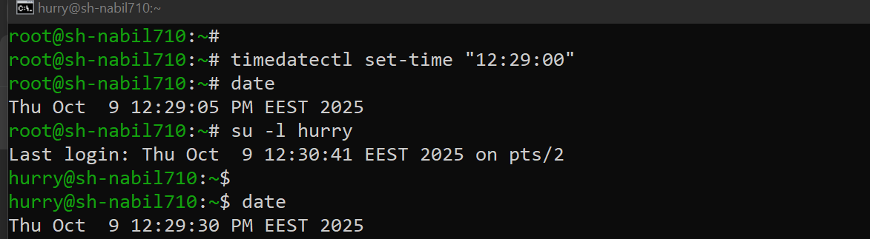

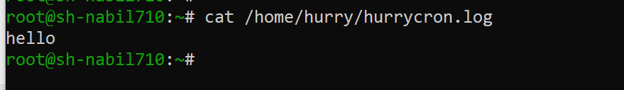

**9. Locate the Files**

**a) Locate all the files owned by sarah and make a copy of them in the**

**given path /root/find.user**

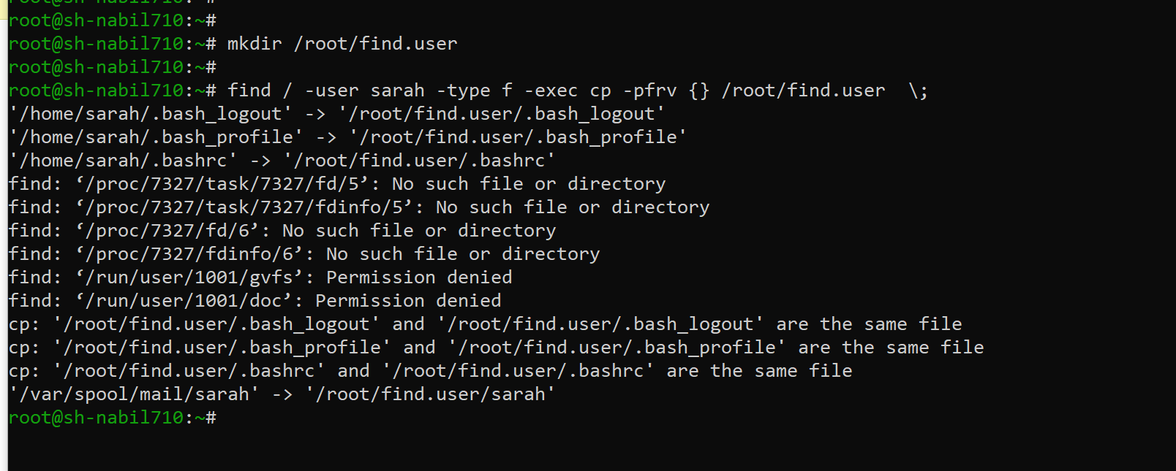

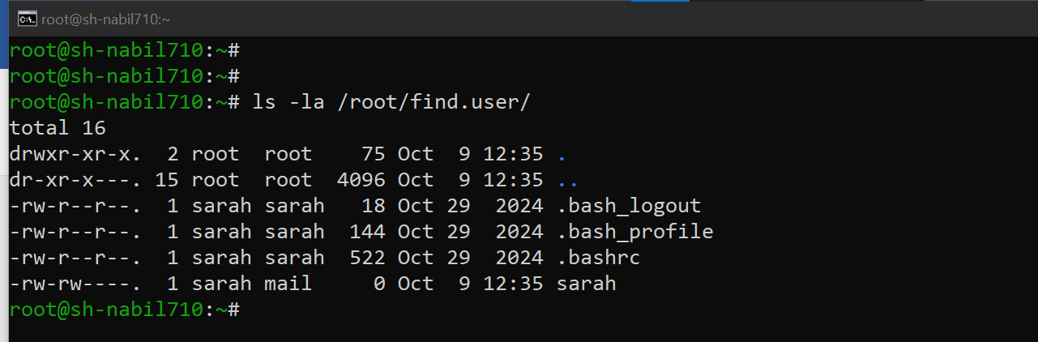

**10. Find the string**

**a) Find a string "home" in /etc/passwd and searching string as been stored in /root/search.txt**

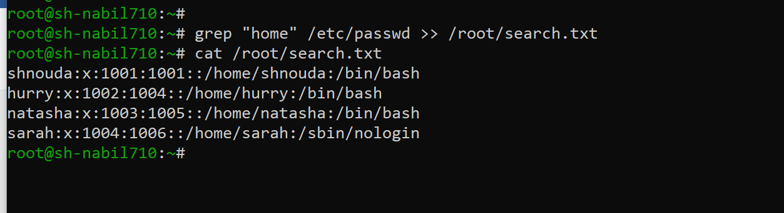

**11. Create an user account**

**a) Create an user account with Userid 1326 and user name as alies**

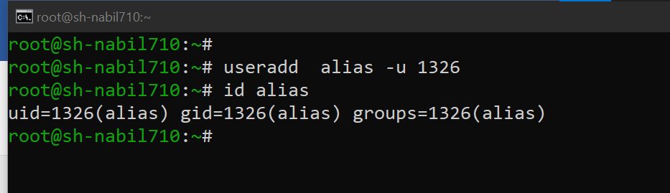

**12. Create a tar archive file**

**a) Backup the /var/tmp as /root/test.tar.gz**

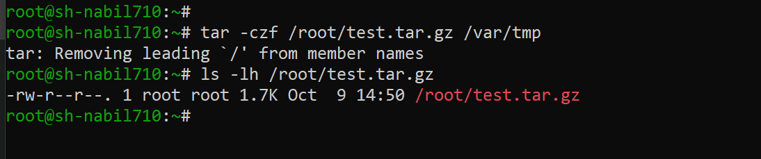

**15.1 Set the Permission**

**a) All new creating files for user natasha as -r-------- as default permission.**

**b) All new creating directories for user natasha as dr-x------ as default permission.**

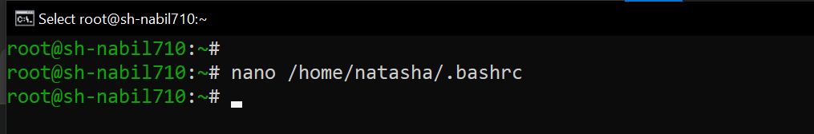

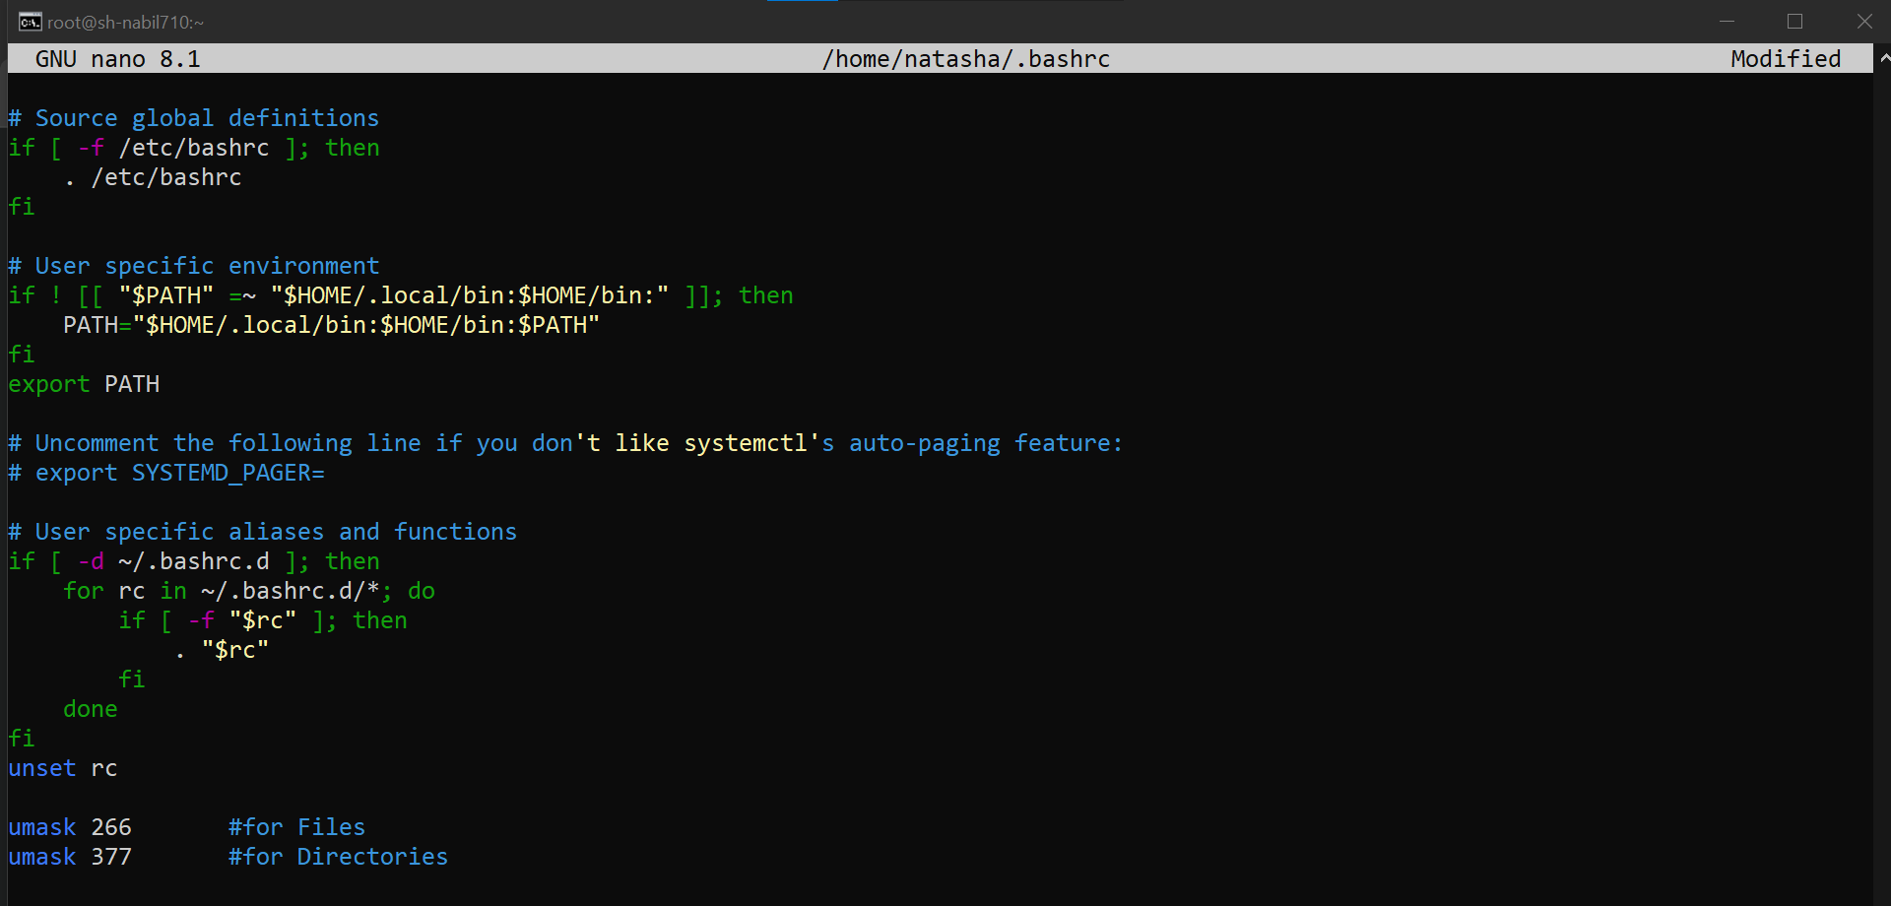

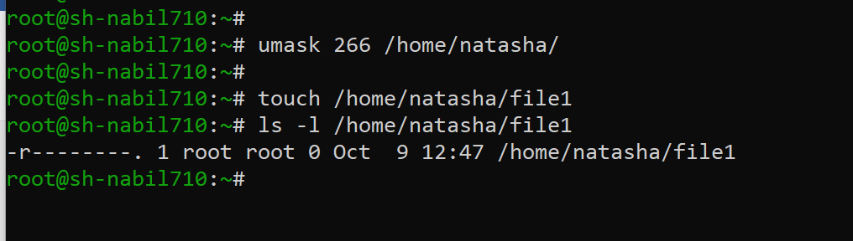

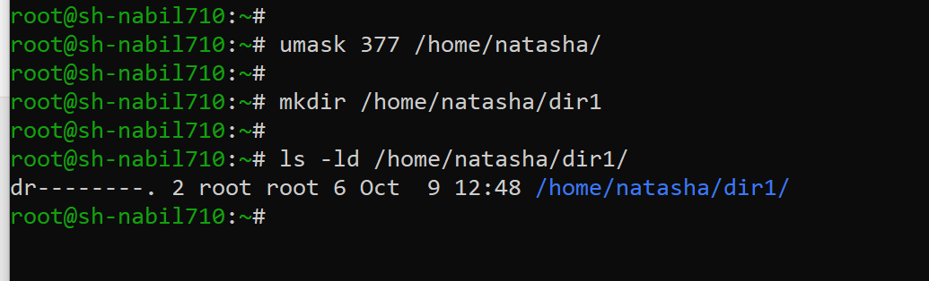

**15.2 Set the Password expire date**

**a) The password for all new users in serverb.lab.example.com should expires after 20 days.**

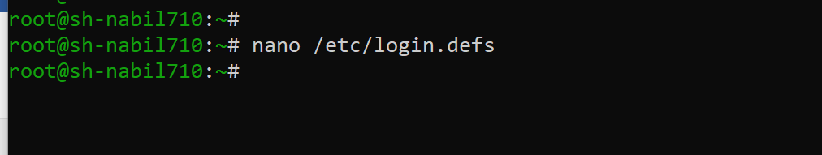

* **I put the Max days for password aging is 20 .**

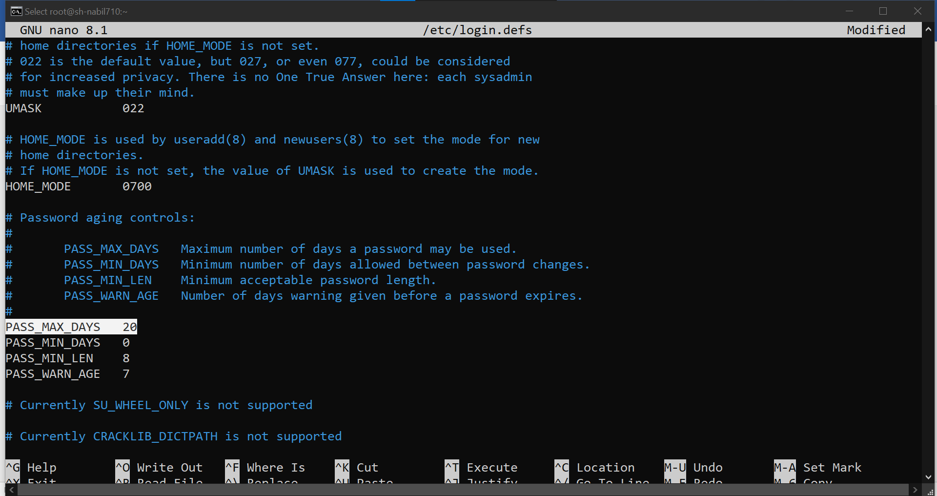

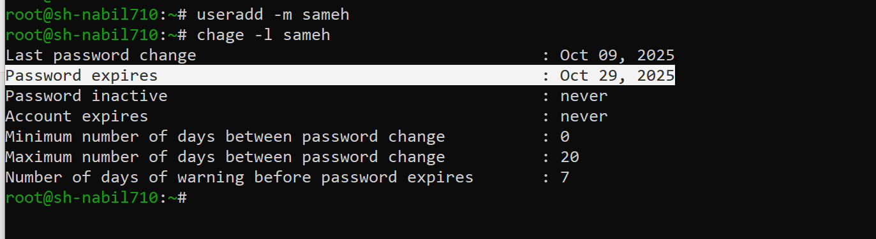

**15.3 Assign Sudo Privilege**

**Assign the Sudo Privilege for Group "admin" and Group members can administrate without any password**

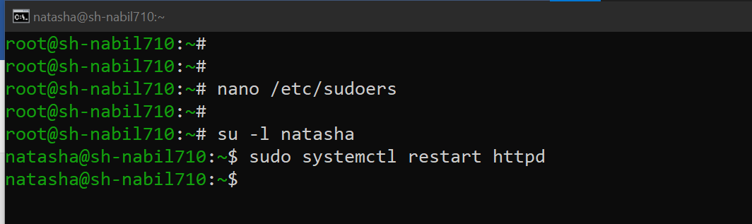

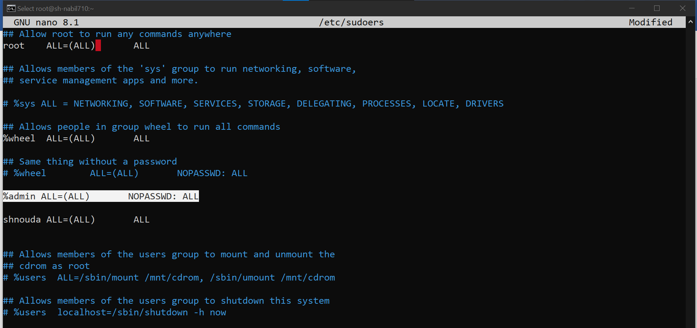

* **To verify.**

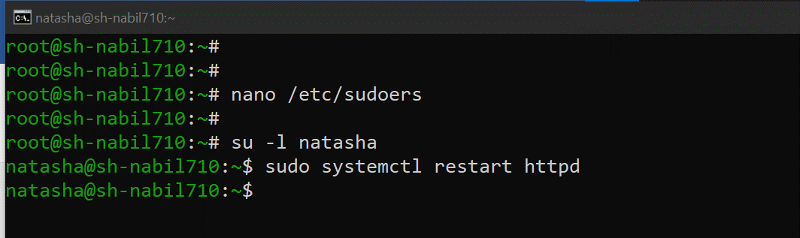

**15.4 Configure the application RHCSA as an alies user, When login it will show the message "Welcome to Advantage Pro"**

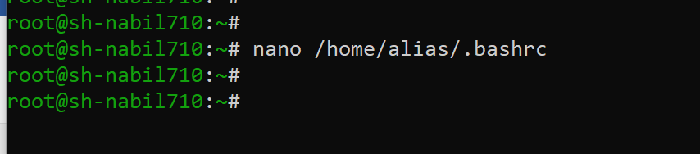

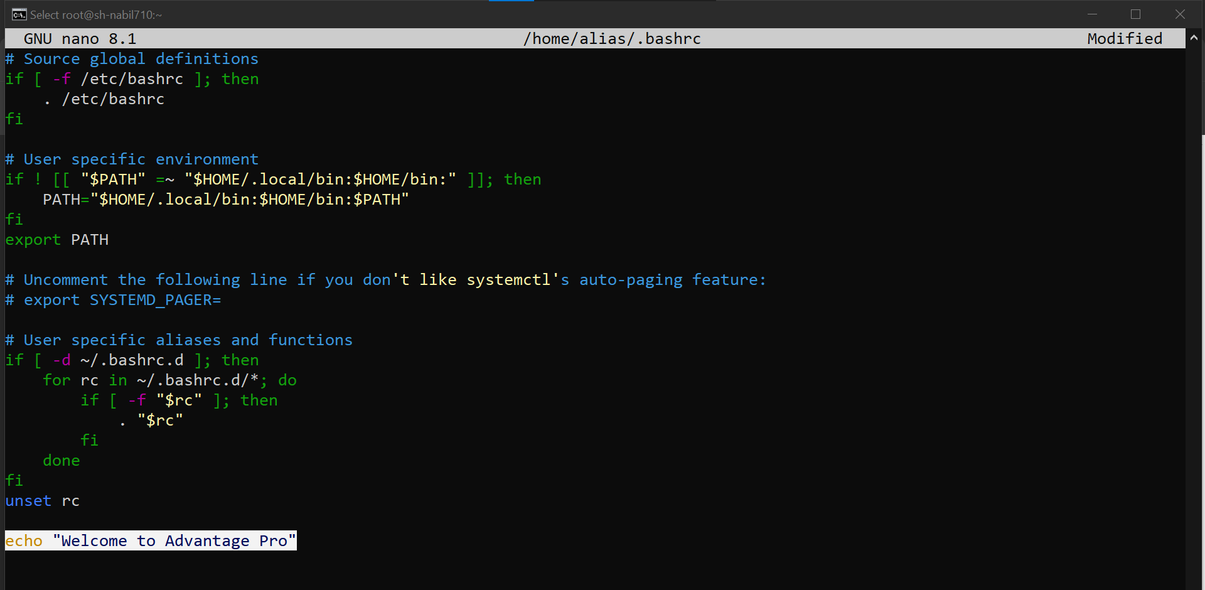

* **To verify**

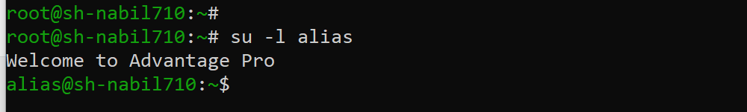

**15.5 Create the script file**

**a) Create a mysearch script file under /usr/local/bin to locate files under /usr/share directory having size less than 1M.**

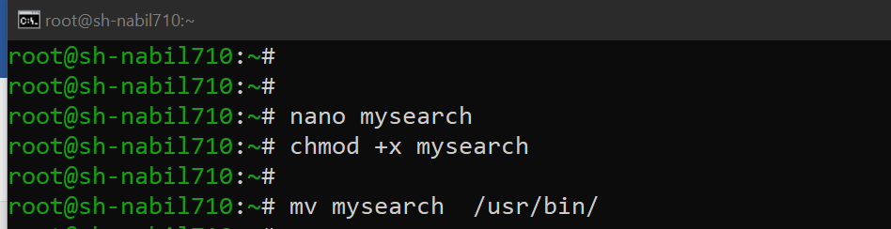

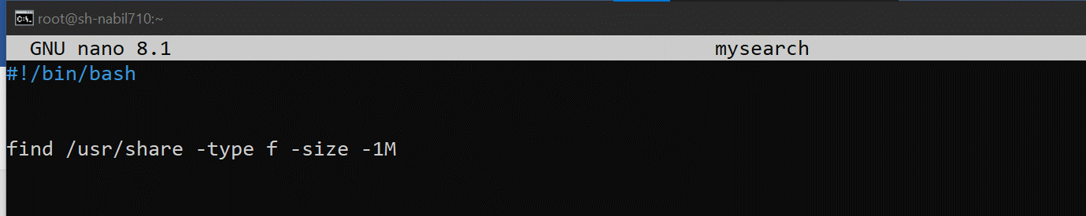

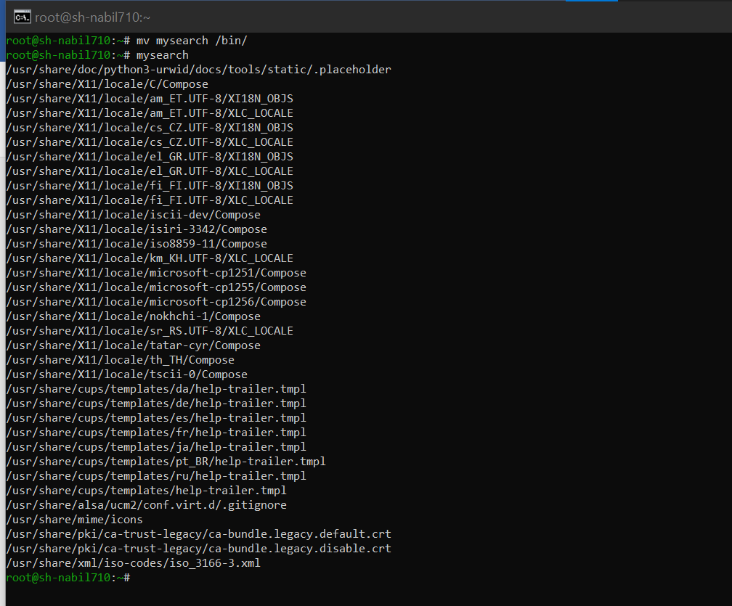

**b) After executing the mysearch script file and listed(searched) files has to be copied under /root/myfiles**

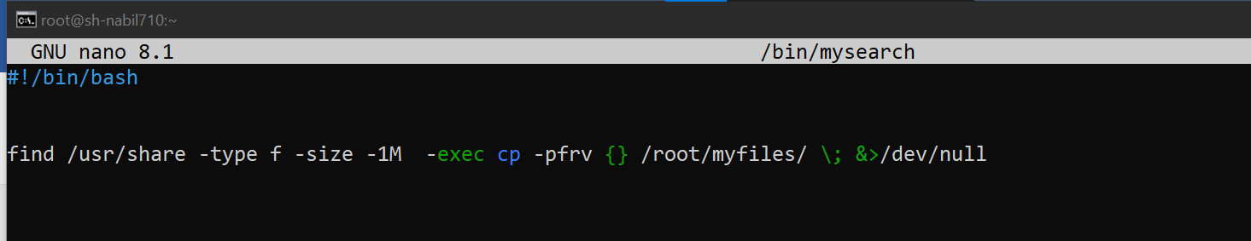

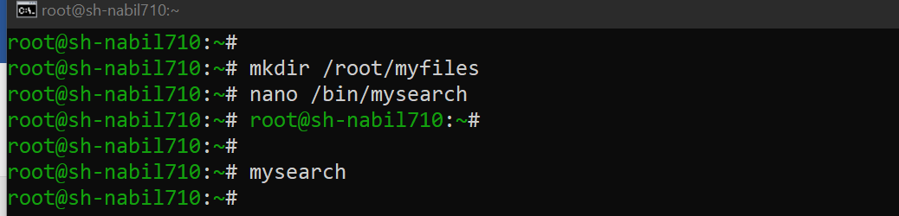

* **To Verify**

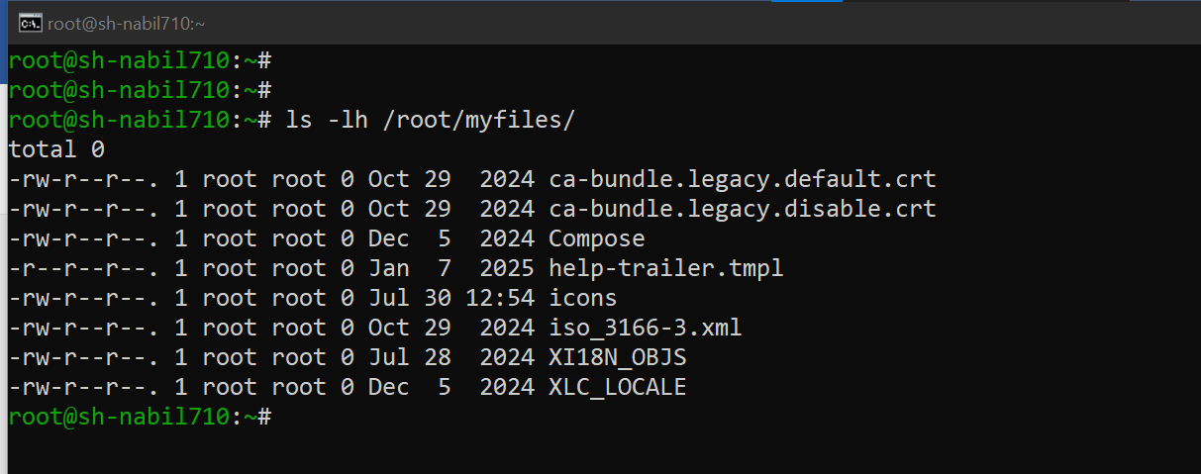

**16. Create a swap partition 512MB size.**

**In this question I will add another hard drive to my machine.**

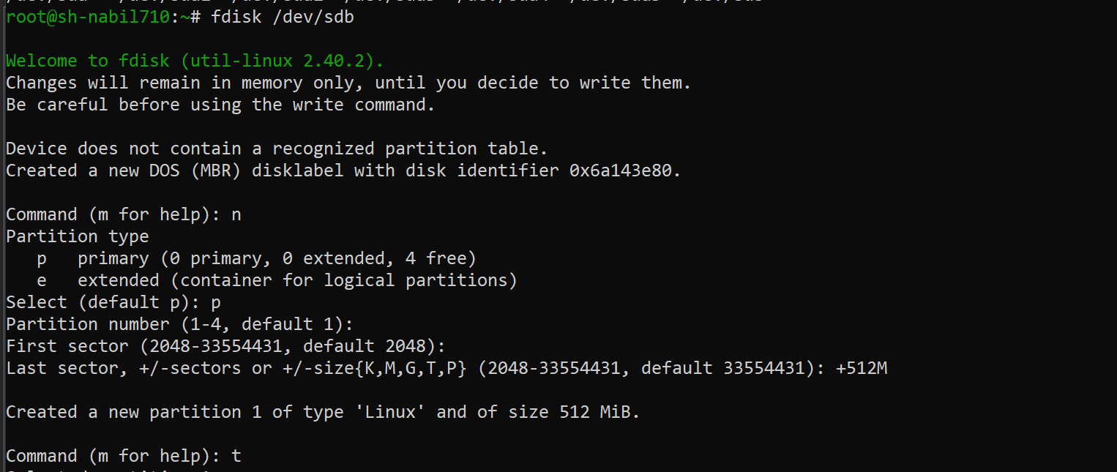

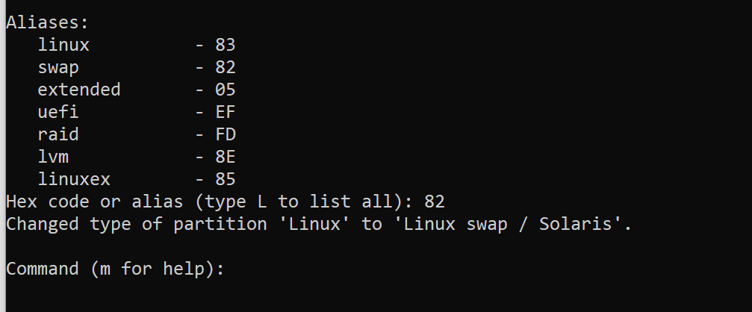

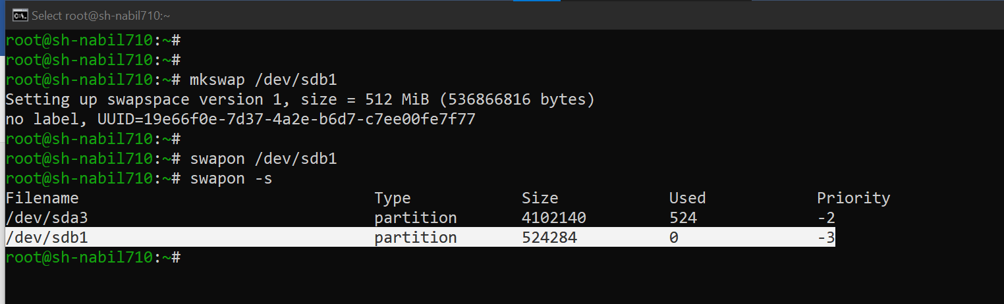

* **To make this as a persistence 🡪 I will this partition in the /etc/fstab file.**

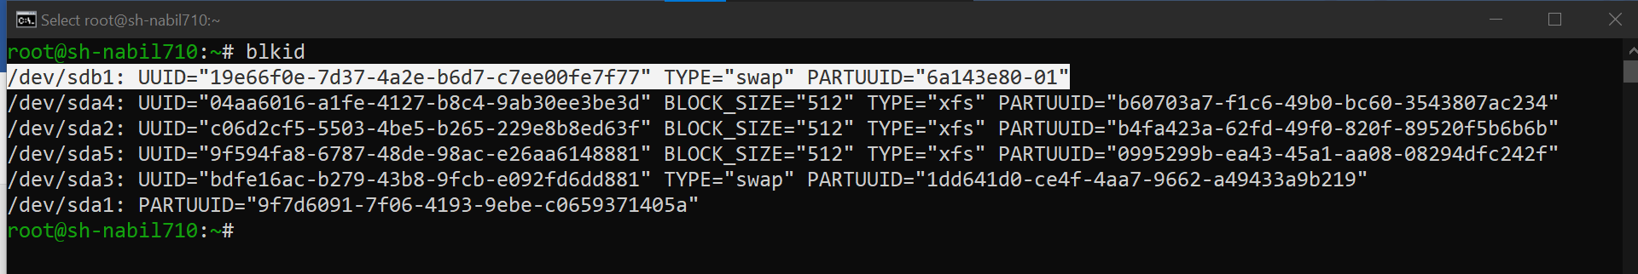

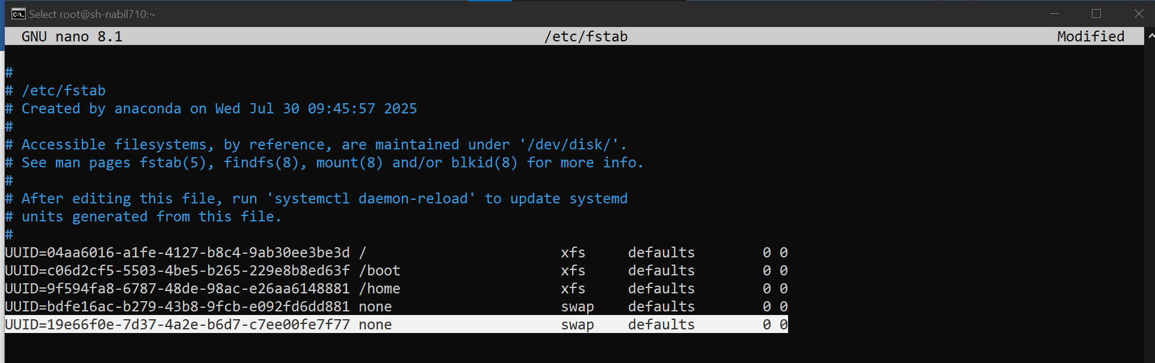

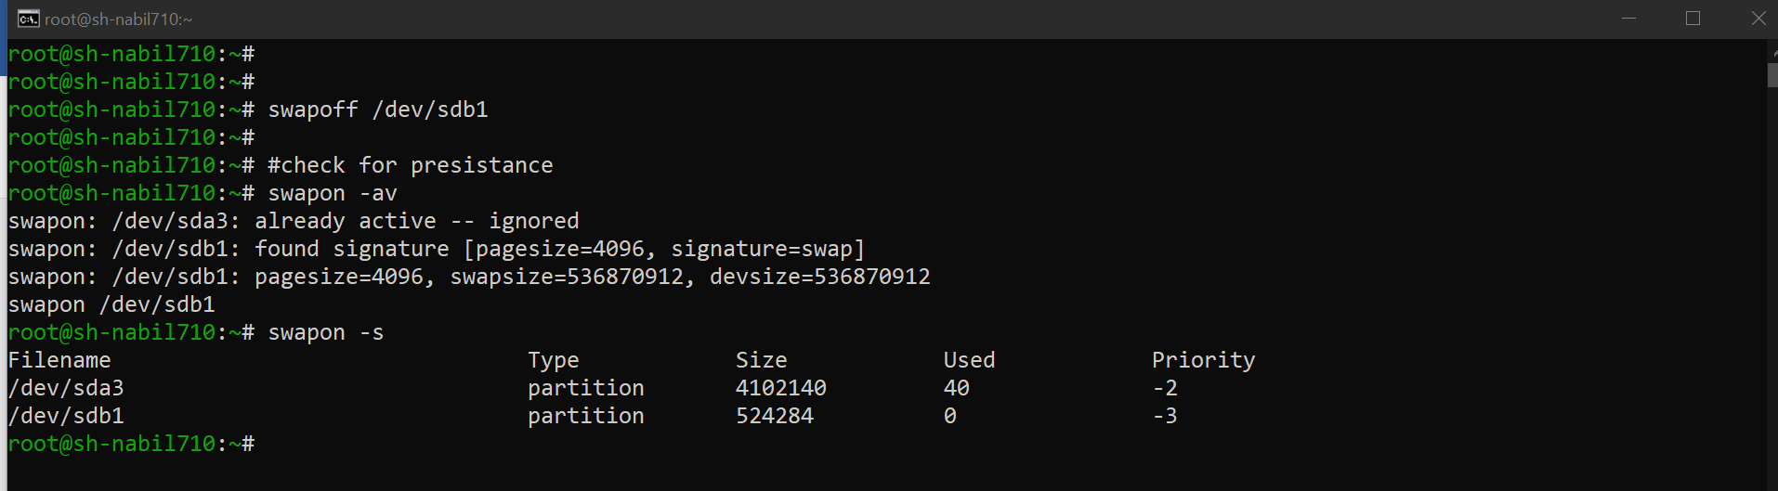

**17- Create one logical volume named database and it should be on datastore volume group**

**with size 50 extent and assign the filesystem as ext3.**

**(i) the datastore volume group extend should be 8MiB. (ii)mount the logical volume under mount point /mnt/database.**

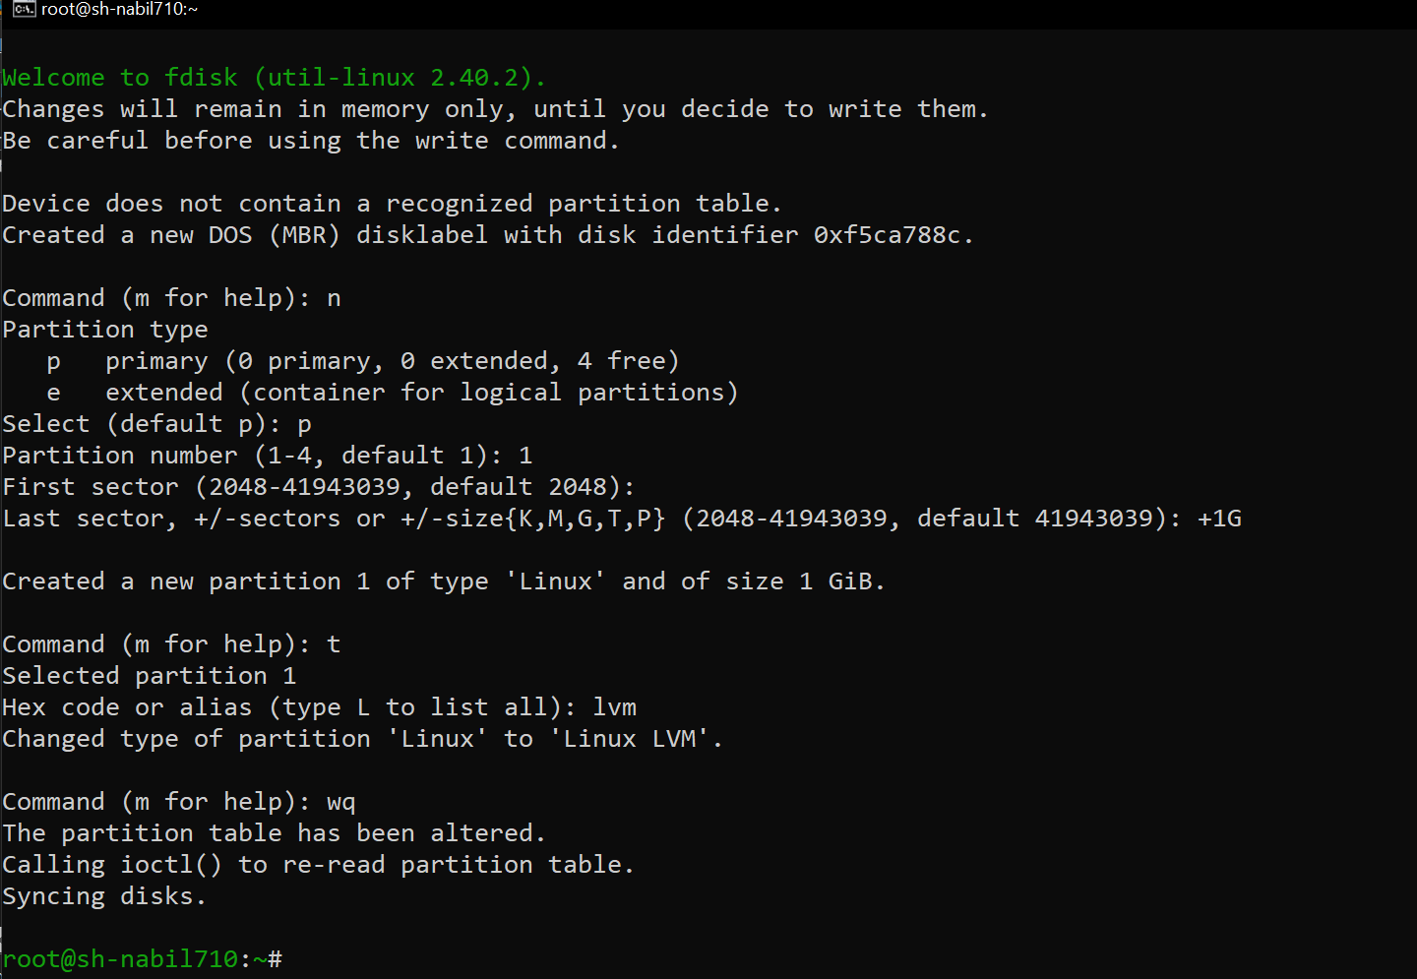

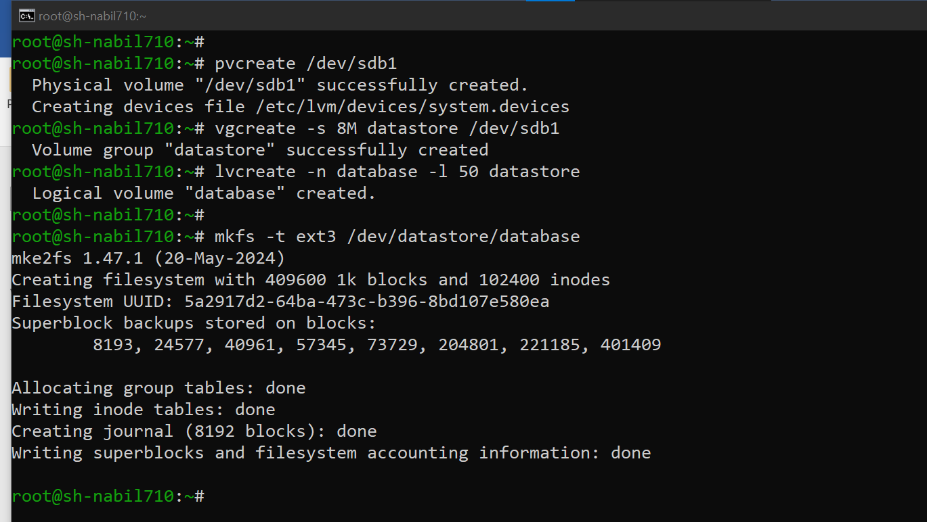

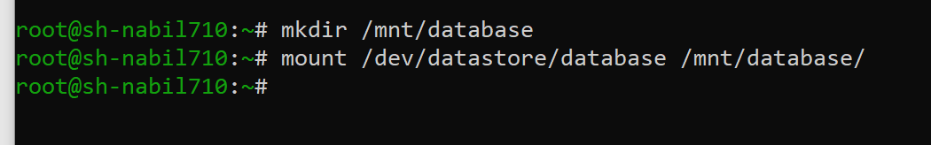

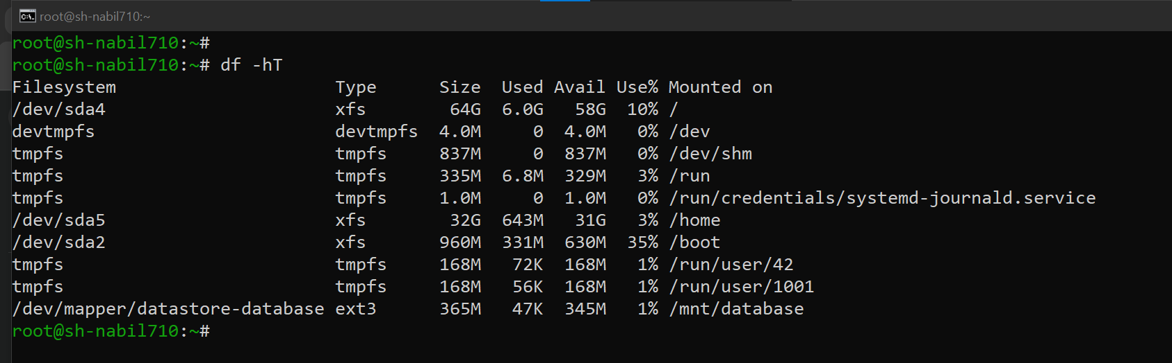

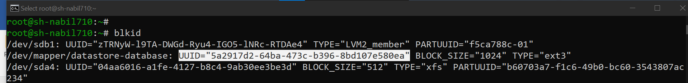

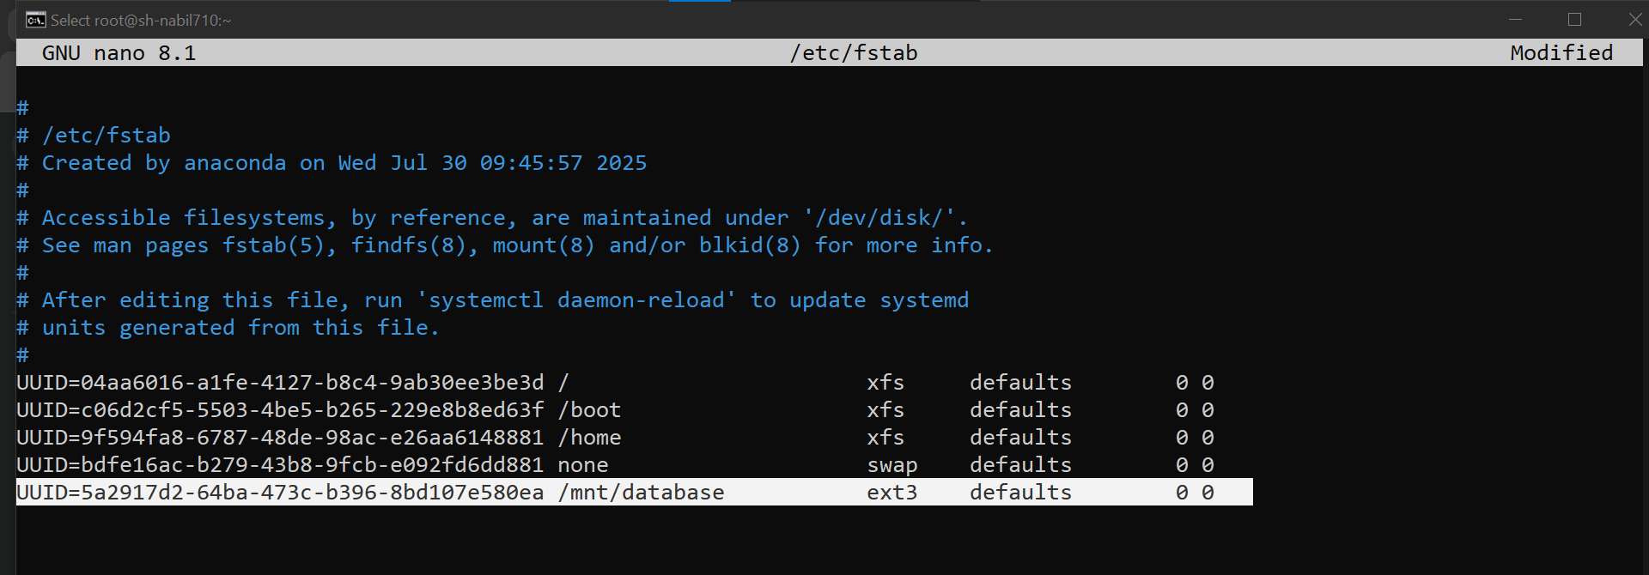

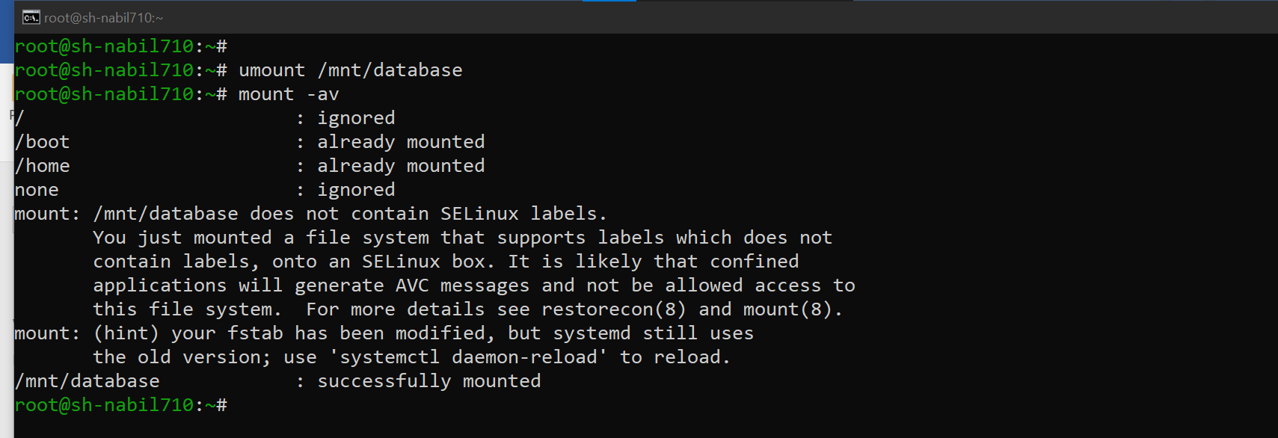

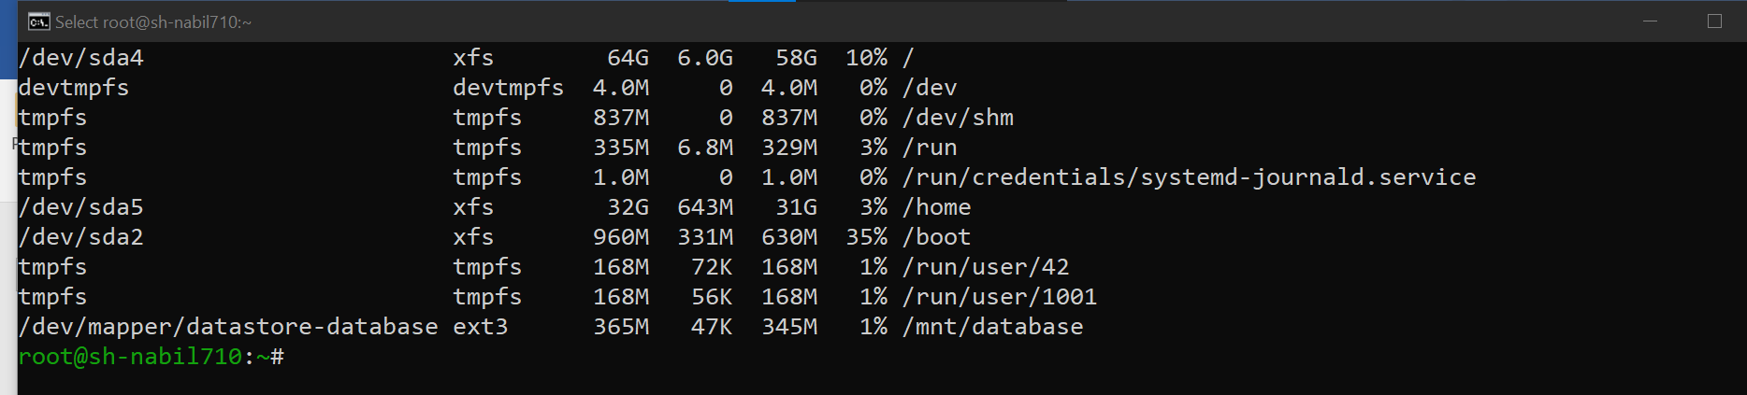

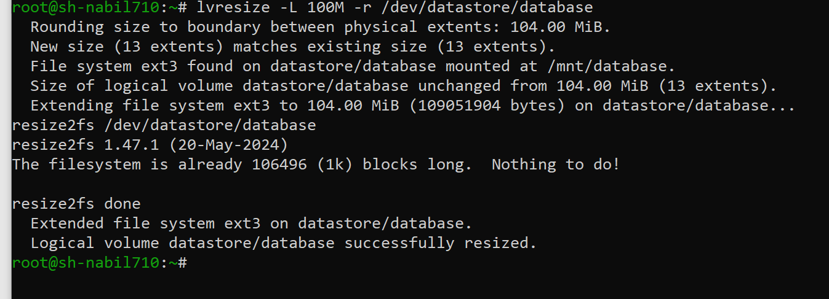

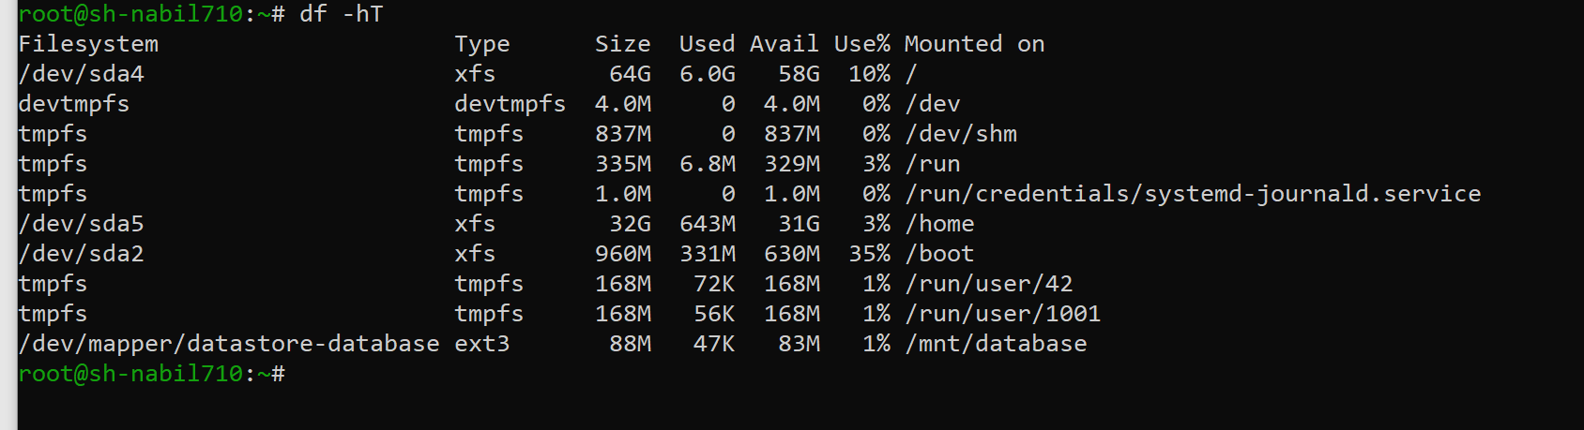

**18- Set the recommend tuned profile for your system.**

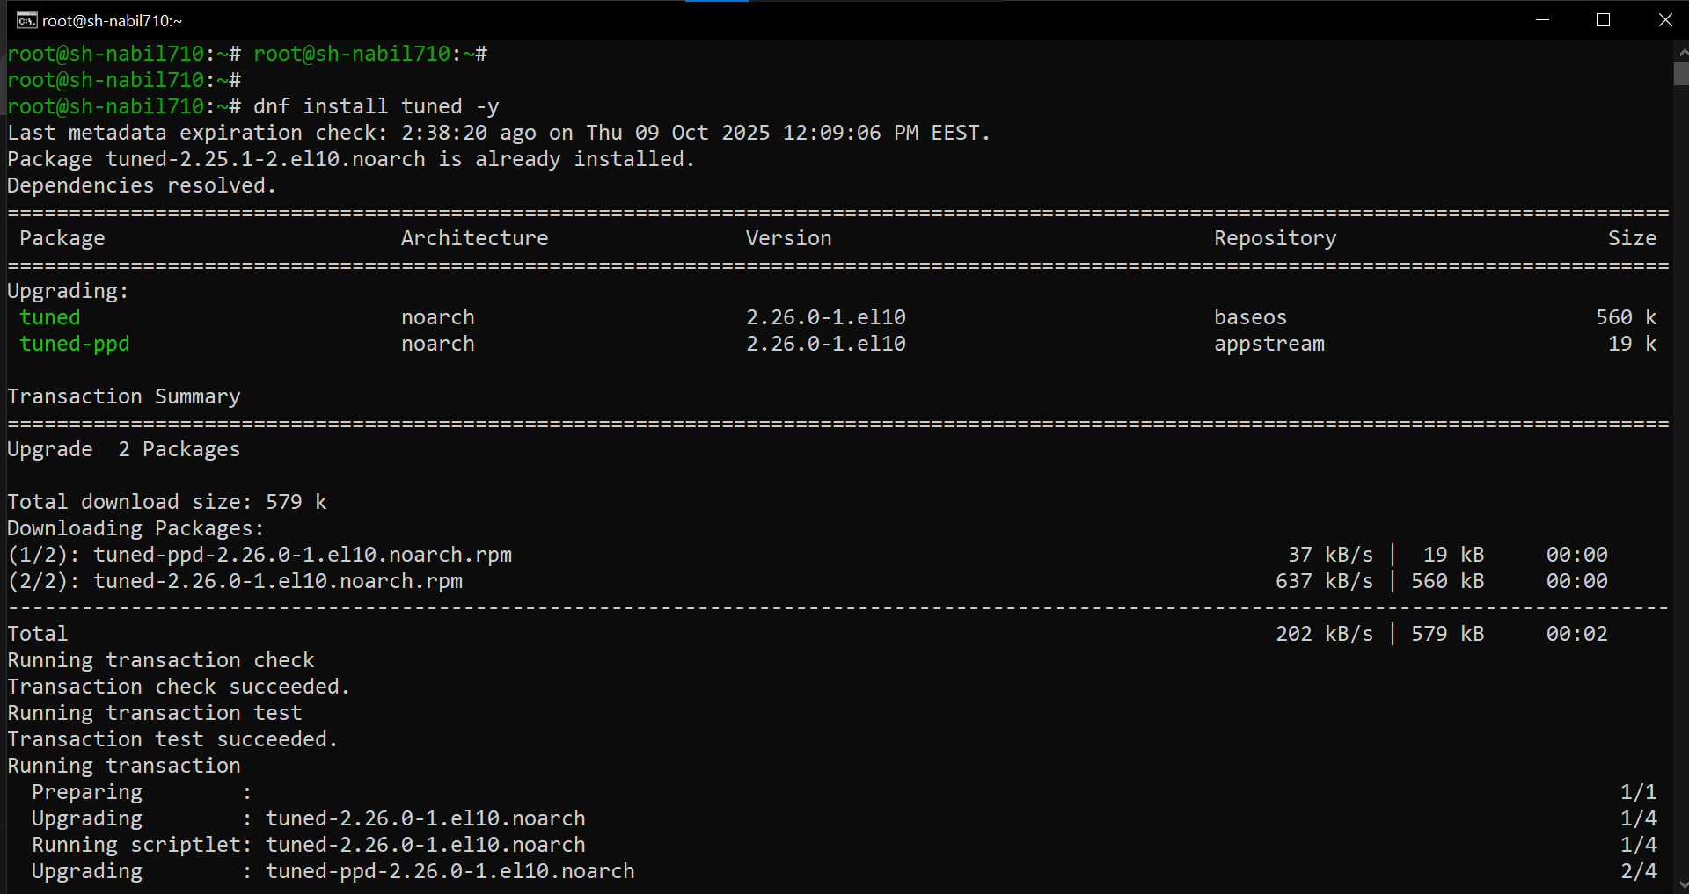

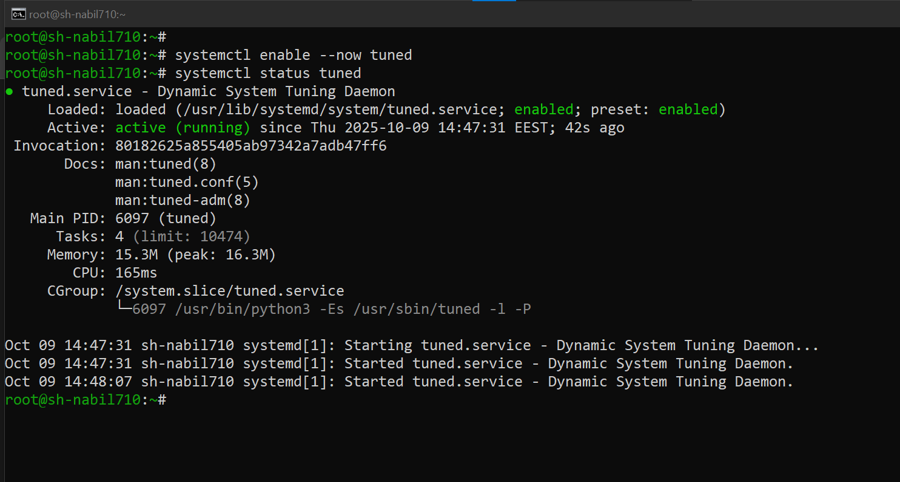

* **To verify:**

